**Weighted regression models**

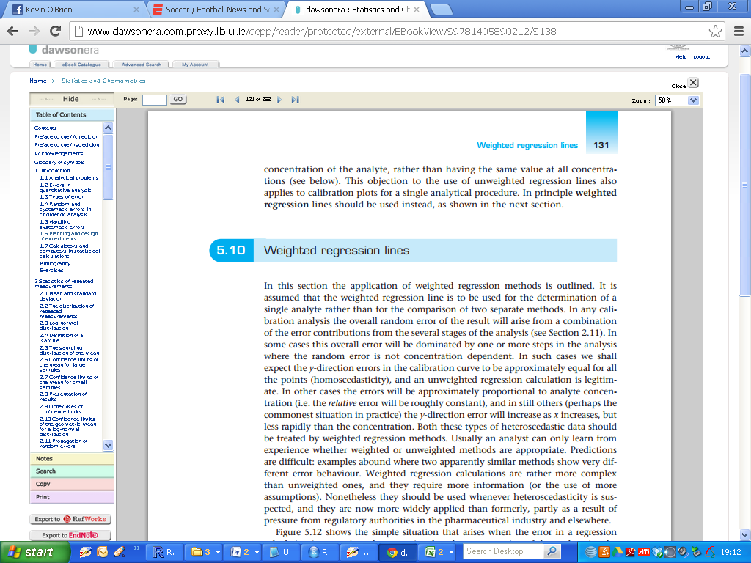

In OLS based simple linear models, we shall expect the y-direction errors in the regression curve to be approximately equal for all the points (***homoscedasticity – i.e. constant variance***) .

If so, then an (unweighted) regression calculation is legitimate.

However, this assumption of ***homoscedascity*** may not be valid, and instead the variance of the residuals may be found to vary across the range of measurements. This is known as ***heteroscedasticity***  (e.g. the “funnel effect”).

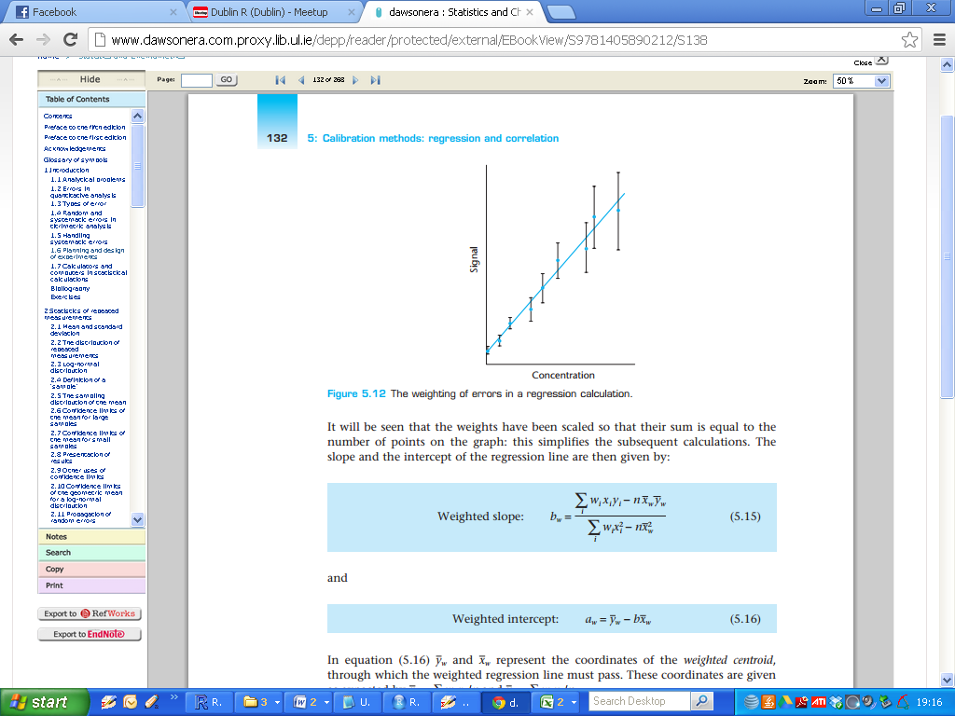

In some cases the errors will be approximately proportional to analyte concentration (i.e. the relative error will be roughly constant), and in still others (perhaps the commonest situation in practice) the y-direction error will increase as x increases, but less rapidly than the concentration.

Both these types of heteroscedastic data should be treated by ***weighted regression methods***. Usually an analyst can only learn from experience whether weighted or unweighted methods are appropriate.

Predictions are difficult: examples abound where two apparently similar methods show very different error behaviour. Weighted regression calculations are rather more complex than unweighted ones, and they require more information (or the use of more assumptions).

Nonetheless they should be used whenever heteroscedasticity is suspected, and they are now more widely applied than formerly, partly as a result of pressure from regulatory authorities in the pharmaceutical industry and elsewhere.

Figure 5.12 (last page) shows the simple situation that arises when the error in a regression calculation is approximately proportional to the concentration of the analyte, i.e. the ‘error bars' used to express the random errors at different points on the calibration get larger as the concentration increases.

The regression line must be calculated to give additional weight to those points where the error bars are smallest: it is more important for the calculated line to pass close to such points than to pass close to the points representing higher concentrations with the largest errors.

This result is achieved by giving each point a weighting inversely proportional to the corresponding variance, s2i.

(This logical procedure applies to all weighted regression calculations, not just those where the y-direction error is proportional to x.)

Thus, if the individual points are denoted by (x1, y1), (x2, y2), etc. as usual, and the corresponding standard deviations are s1, s2, etc., then the individual weights, w1, w2, etc., are given by:

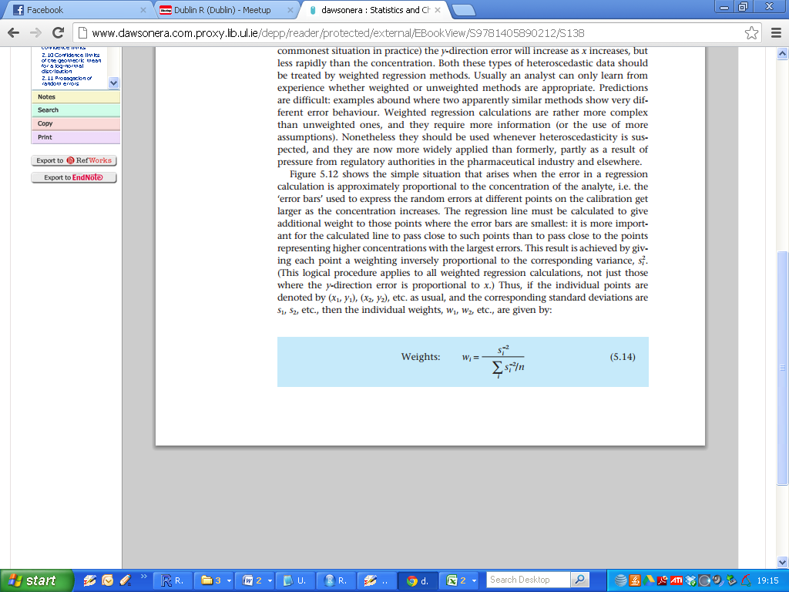

It will be seen that the weights have been scaled so that their sum is equal to the number of points on the graph: this simplifies the subsequent calculations.

The slope and the intercept of the regression line are then given by:



and



**Weighted Centroid**

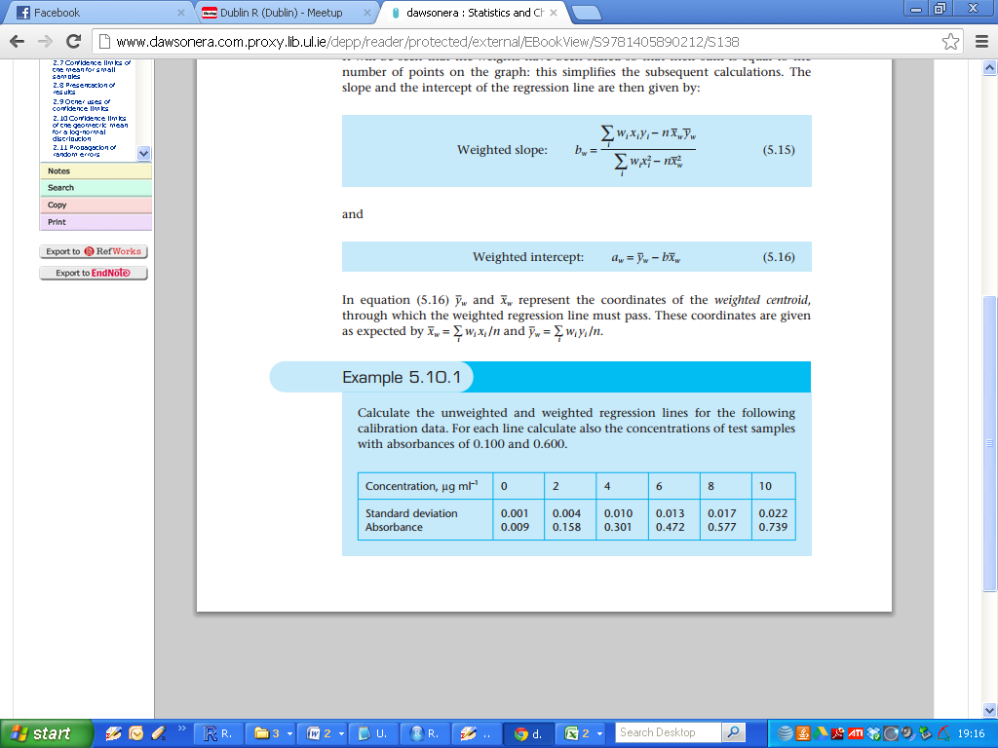

The unweighted centroids are simply the means of the observations for both the independent and dependent variables: $\overline{x,} \overline{y}$. The Simple linear regression fitted line must past through these centroids.



|  |
| --- |
| Conc=(0,2,4,6,8,10)  Abso=(0.009,0.158,0.301,0.472,0.577,0.739) |

**Simple Linear Regression Model**

|  |
| --- |
| > Fit1 = lm(Abso~Conc)  > summary(Fit1)  Call:  lm(formula = Abso ~ Conc)  Residuals:  1 2 3 4 5 6  -0.0042857 -0.0003714 -0.0024571 0.0234571 -0.0166286 0.0002857  Coefficients:  Estimate Std. Error t value Pr(>|t|)  (Intercept) 0.013286 0.010559 1.258 0.277  Conc 0.072543 0.001744 41.602 2e-06 ***  ---  Signif. codes: 0 ‘***’ 0.001 ‘**’ 0.01 ‘*’ 0.05 ‘.’ 0.1 ‘ ’ 1  Residual standard error: 0.01459 on 4 degrees of freedom  Multiple R-squared: 0.9977, Adjusted R-squared: 0.9971  F-statistic: 1731 on 1 and 4 DF, p-value: 1.995e-06 |

***Regression Equation : Abso = 0.0132 + 0.0725Conc***

**Weighted Regression Model**

|  |
| --- |
| > Abso.sd=c(0.001,0.004,0.010,0.013,0.017,0.022)  > weights=Abso.sd^(-2)/mean(Abso.sd^(-2))  > summary(Fit2)  Call:  lm(formula = Abso ~ Conc, weights = weights)  Weighted Residuals:  1 2 3 4 5 6  -0.0001974 0.0008212 -0.0007349 0.0036841 -0.0030674 -0.0008217  Coefficients:  Estimate Std. Error t value Pr(>|t|)  (Intercept) 0.009084 0.001048 8.671 0.000974 ***  Conc 0.073760 0.001064 69.330 2.59e-07 ***  ---  Signif. codes: 0 ‘***’ 0.001 ‘**’ 0.01 ‘*’ 0.05 ‘.’ 0.1 ‘ ’ 1  Residual standard error: 0.002495 on 4 degrees of freedom  Multiple R-squared: 0.9992, Adjusted R-squared: 0.999  F-statistic: 4807 on 1 and 4 DF, p-value: 2.593e-07 |

***Regression Equation : Abso = 0.0090 + 0.0737Conc***

From the book: (Not discussed in lectures, apart from predicted values)

Results of predicted values for ***X = 0.100*** and ***0.600*** are below.

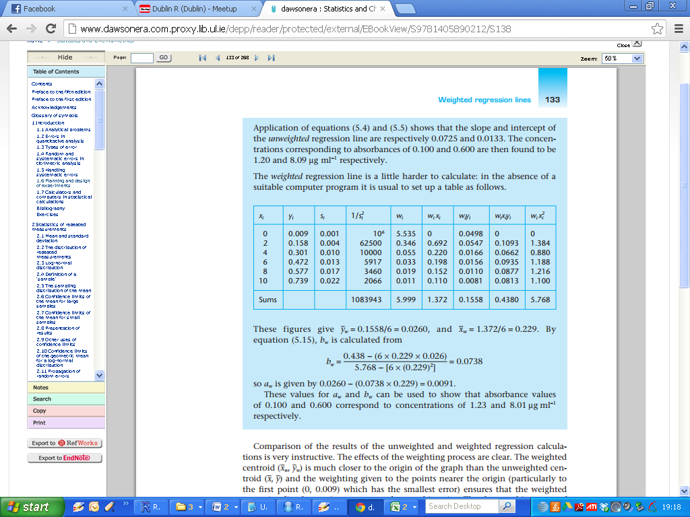

Comparison of the results of the unweighted and weighted regression calculations is very instructive.

|  |  |
| --- | --- |
| ***Weighted Centroids:***    ***Unweighted Centroids***   |  | | --- | | > mean(Conc)  [1] 5  > mean(Abso)  [1] 0.376 | |

The effects of the weighting process are clear. The ***weighted centroid*** is much closer to the origin of the graph than the ***unweighted centroid*** and the weighting given to the points nearer the origin (particularly to the first point (0, 0.009) which has the smallest error) ensures that the weighted regression line has an intercept very close to this point.

The slope and intercept of the weighted line are remarkably similar to those of the unweighted line, however, with the result that the two methods give very similar values for the concentrations of samples having absorbances of 0.100 and 0.600. It must not be supposed that these similar values arise simply because in this example the experimental points fit a straight line very well.

In practice the weighted and unweighted regression lines derived from a set of experimental data have similar slopes and intercepts even if the scatter of the points about the line is substantial.

As a result it might seem that weighted regression calculations have little to recommend them. They require more information (in the form of estimates of the standard deviation at various points on the graph), and are far more complex to execute, but they seem to provide data that are remarkably similar to those obtained from the much simpler unweighted regression method.

Such considerations may indeed account for some of the neglect of weighted regression calculations in practice. But an analytical chemist using instrumental methods does not employ regression calculations simply to determine the slope and intercept of the calibration (i.e. regression) plot and the concentrations of test samples.

There is also a need to obtain estimates of the errors or confidence limits of those concentrations, and it is in this context that the weighted regression method provides much more realistic results.